**Milestone 01 Report**

*Zhaoyang Chen, Jieming Fan, Bingjie Zhu, Manqin Zhong*

**EECS 149 Fall 2019**

**GitHub repo:** <https://github.com/CZhaoYoung/EECS149-Group-project>

**Architecture Drawing:**

The overview of the system of our system consists of five parts:

**BLE communication.** The command is sent to leader kobuki from the computer and then the leader kobuki will advertise the commands to other kobukis to realize communication from each other.

**Distance Measurement.** We will use ultra-wideband transceivers to detect the distance between each kobukis. Suppose one kobuki sends messages via ultra wideband. When one of the followers receive the messages, it will send them back as a response to make sure that the distance being measured is exactly between the two kobukis.

**Coordinate System Establishment.** As we have measured the distances between each kobuki, we can build a coordinate system by setting the location of the leader kobuki as an origin.

**Task Performance.** Since we have pined the distance from each kobuki, we will let the kobukis to form an equilateral triangle.

**Deploy & Test.** Final testing. Deploy the kobukis in more complicated environments.

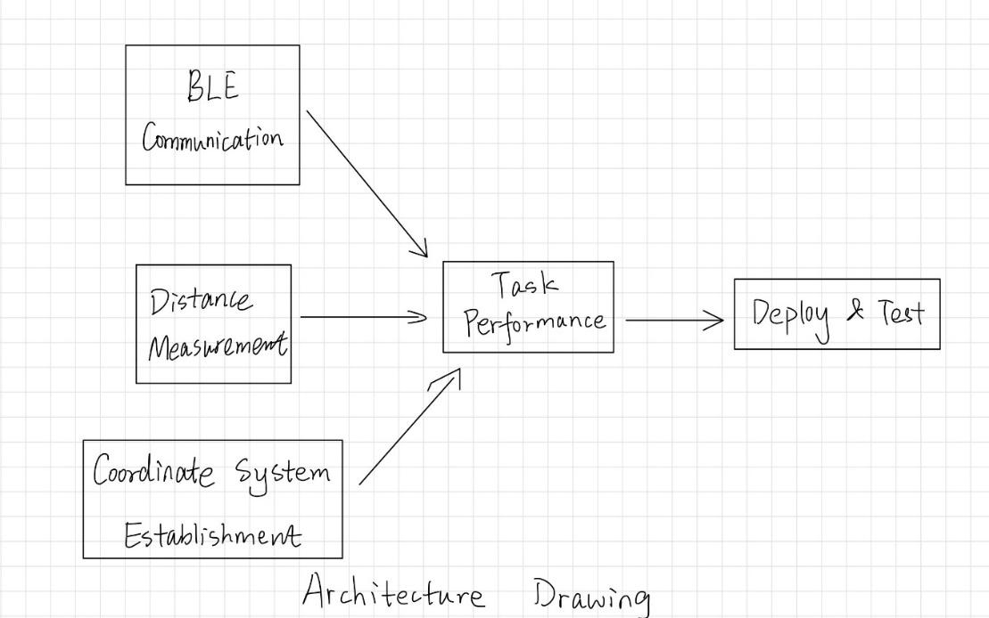

Figure 1: Architecture Drawing of our project

**State machine :**

Leader kobuki receives the commands and enter *RUN* state. Then it will perform the action corresponding to the commands it receives. After that, the leader will advertise these commands to followers.

The followers who receive the commands will do actions just like the leader.

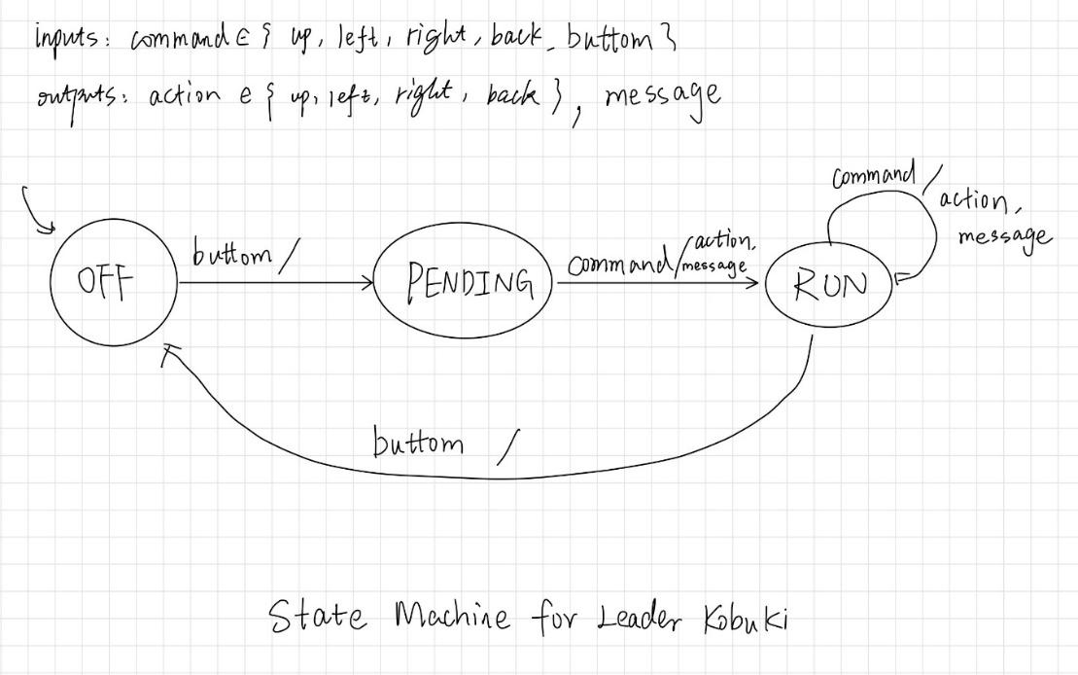

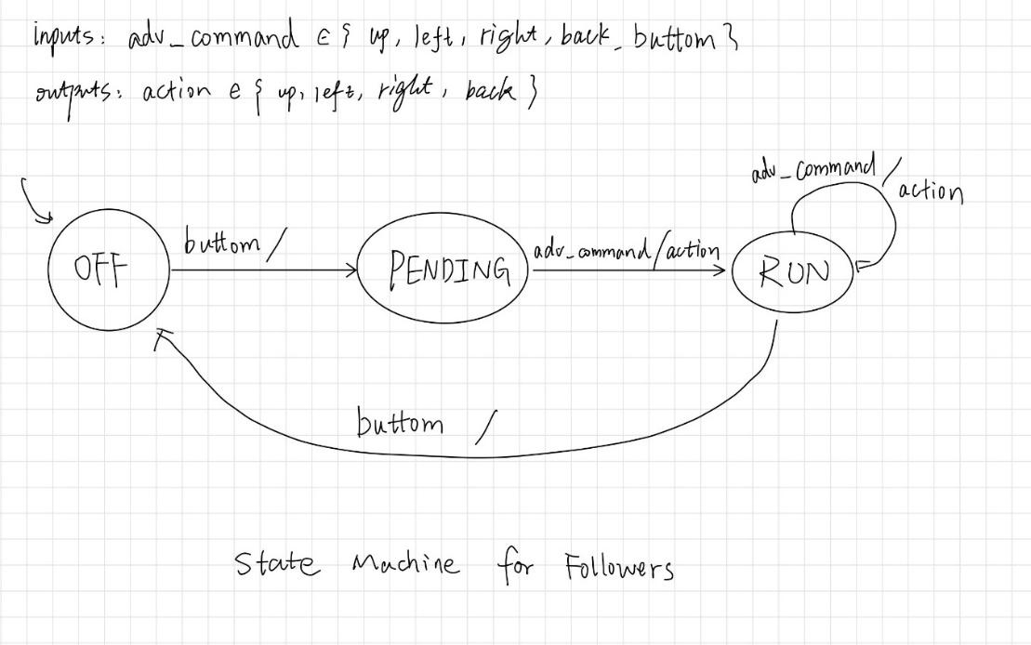

Figure 2: State machines for leader Kobuki and the followers

**Progress:**

At the milestone 01 we have finished the BLE communication module. In this module, we built a BLE service between computer and leader kobuki. And then the leader kobuki will advertise the commands to other followers.

**Modifications to goals:**

Based on progress and feasibility of our project, we decided to use ultra-wideband transceiver instead of cameras to detect the distances between each kobuki.

**List of necessary resources**

Hardware:

DWM1001C ultra wideband transceiver, nRF52 Development Kit, Berkeley Bulker, Kobuki,

Software:

Buckler repo, BLE libraries, NRF SDK,

**Schedule of remaining time**

November 8: BLE communication implement and testing

November 17: Milestone02, use ultra-wideband transceiver to measure the distance, testing

November 25: Build the coordinate system to pin the position of each kobuki, testing

December 2: Let the kobukis to perform some tasks though BLE, testing

December 9: Final System testing.

December 13: Demonstration video made, posters and report prepared.

December 17: Final presentation and demo. December 19: Project report and video turned in.

**Identification of major risks**

We need to consider the drifts of each kobukis, which will be a tricky task in the coming weeks. It is challenging if the kobuki do not follow the route we set.